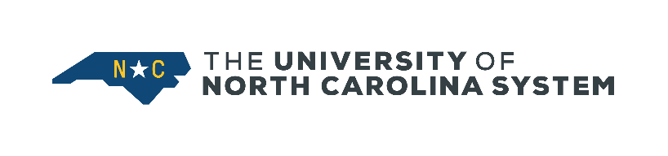
MEETING OF THE BOARD OF GOVERNORS

May 25, 2023, at 10 a.m.
Via Videoconference and PBS North Carolina Livestream
UNC System Office, Board Room
223 S. West Street
Raleigh, North Carolina

AGENDA
OPEN SESSION
- Invocation Mrs. Nichols
- Roll Call Secretary Burris-Floyd
- Administration of the Oath of Office……………..…………………………………….Associate Justice Berger, Jr.
- Presentation of the 2023 Oliver Max Gardner Award ...Mrs. Nelson

- President’s Report President Hans

- Chair’s Report Chair Ramsey

- Consent Agenda Chair Ramsey
Minutes
  - Minutes (Open) of April 20, 2023
Committee on Budget and Finance
  - FY 2022 UNC System Debt Capacity Study
  - Capital Improvement Projects

Committee on Educational Planning, Policies, and Programs
  - UNC System Academic Degree Programs

Committee on University Personnel
  - Section 101.3.2 of the UNC Policy Manual, Policy on Grievances Filed Pursuant to Section 607 of The Code (repeal) (approved April 19, 2023)
  - Section 101.3.3 of the UNC Policy Manual, Policy on Delivery of Notices (repeal) (approved April 19, 2023)
  - Section 100.1 of the UNC Policy Manual, The Code Chapter V (amend) (approved April 19, 2023)
  - Section 100.1 of the UNC Policy Manual, The Code Chapter VI (amend) (approved April 19, 2023)
  - Section 100.1 of the UNC Policy Manual, The Code Chapter VII (amend) (approved April 19, 2023)
  - Section 100.1 of the UNC Policy Manual, The Code Appendix 1 (amend) (approved April 19, 2023)

Committee on University Governance
k. Section 200.8 of the UNC Policy Manual, Policy on Chancellor Searches and Elections (amend) (approved April 19, 2023)

- Report of the Committee on Audit, Risk Management, and Compliance……………..….Mr. Hutchens
  - Presentation of the State Auditor of North Carolina…………..……………………………Ms. Wood

- Report of the Committee on Budget and Finance………………………………………………………Mr. Roberts

- Report of the Committee on Educational Planning, Policies, and Programs Mr. Sloan
  - Report of the Faculty Assembly………………………………………………………………………….Mr. Maki

- Report of the Committee on University Governance Mrs. Blue
  - May 2023 Board of Trustees Appointments
  - North Carolina Arboretum Board of Directors Appointments
  - UNC Press Board of Governors Appointments

- Recognition of Outgoing Members of the Board of Governors………………………………..Chair Ramsey

CLOSED SESSION
- Approval of Minutes (Closed) of April 20, 2023 Chair Ramsey
- Legal Affairs Report Mr. Tripp
- President’s Report President Hans
- Report of the Committee on University Personnel Ms. Coward
OPEN SESSION
- Report of the Committee on University Personnel Ms. Coward
  - Delegation of Authority to the President to Issue Instructions for SHRA and EHRA Annual Raise Process

- Adjourn

The next regularly scheduled meeting of the Board of Governors is Thursday, July 20, 2023, at the University of North Carolina System Office, Raleigh, NC.

